**Lab 1: Getting Started with C++**

**Part A**: Learn how to use the cin and cout in C++.

1. Write a program that to display the following output:

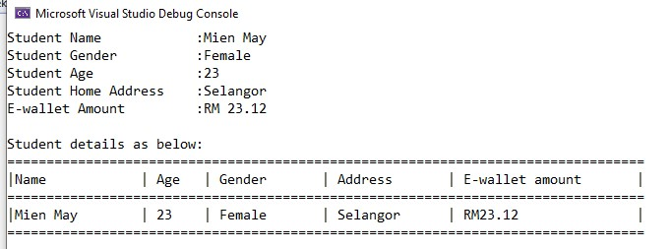

*[*

*Estimate Finish Time:*

*20*

*minutes]*

Answer;

Output:

1. Modify the program in Question 1 to get another output as below: A screenshot of a computer

   AI-generated content may be incorrect.

*[Estimate Finish Time: 15 minutes]*

Answer:

Output:

**Part B**: Learn how to use the Control statements in C++.

1. A program is required to prompt for and accept a time and compute the number of seconds elapsed since midnight. The time should be entered in the format HH:MM:SS. Include some input validations in your program.

**Output sample:**

Please enter your elapsed time (in HH:MM:SS format) = 00:02:44 Elapsed time in seconds = 164 seconds

*[Estimate Finish Time: 30 minutes]*

*Answer:*

Output:

1. Create a simple game in C++ that can let the user guess a random number which secretly selected from the system. The output should be similar as below:

*[Estimate Finish Time: 30 minutes]*

Answer:

Output:

**Part C: Practice Yourself with More Questions.**

Submit your answer (*in doc / pdf*) to Moodle before 17 November 2023. Your answer should include your code and your program screenshot.

1. Create a calendar application by using C++. The output should be similar as below:

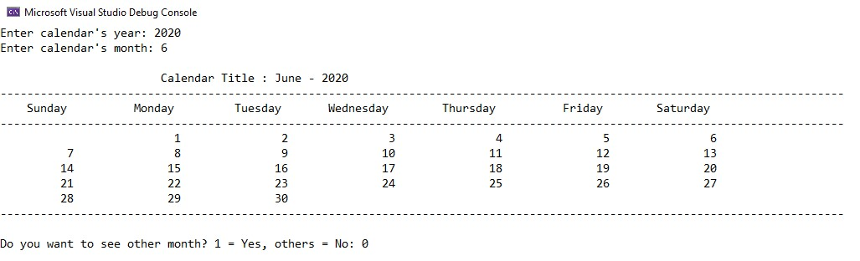

*[*

*Estimate Finish Time*

*:*

*45*

*minutes]*

**Code:**

Output:

1. Develop an interactive program that will keep track of the weather forecast in a month. On any given day, the weather forecast may be hot, rainy, or cloudy. Your program should input the weather forecast for each day in the month and should display the number of hot, rainy, and cloudy days in a month. You should use a loop and a conditional structure to develop this program. Array is not allowed to use in this question.

*[Estimate Finish Time: 45 minutes]*

**Code:**

Output:

3.

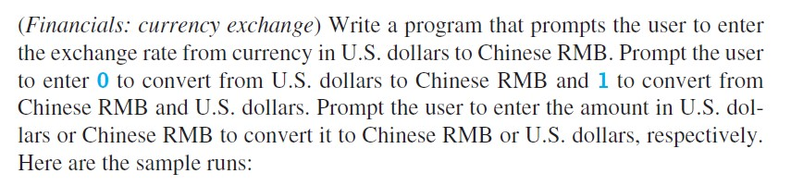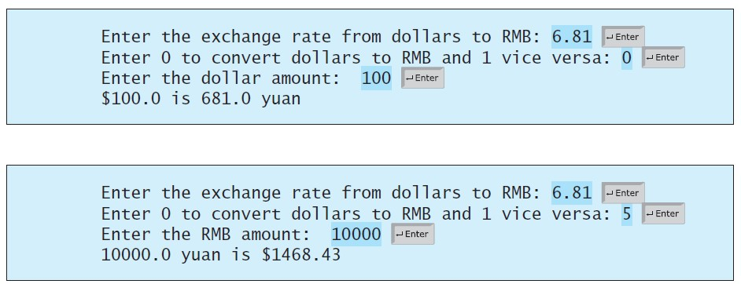

*[*

*Estimate Finish Time:*

*15*

*minutes]*

**Code:**

Output:

1. Write a C++ program ask to the user to enter number of rows for diamond dimension to print the diamond pattern, then display the result on the screen. Note: Must use loops to print the diamond.

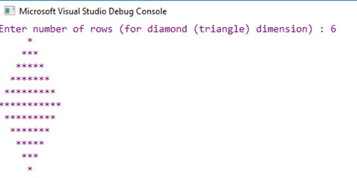

*[*

*Estimate Finish Time:*

*30*

*minutes]*

**Code:**

Output:

1. Write a program that can print the even numbers that in the between of 1 to 50.

**Output sample:**

|  |  |  |  |  |
| --- | --- | --- | --- | --- |
| 2 | 4 | 6 | 8 | 10 |
| 12 | 14 | 16 | 18 | 20 |
| 22 | 24 | 26 | 28 | 30 |
| 32 | 34 | 36 | 38 | 40 |
| 42 | 44 | 46 | 48 | 50 |

*[Estimate Finish Time: 10 minutes]*

**Code:**

Output:

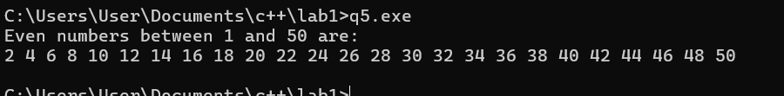

1. Write a program that determines a student’s grade. The program will read three types of scores in percentage (quiz, mid-term, and final scores) and determine the grade based on the following rules:

*if the average score =90% =>grade=A if the average score >= 70% and <90% => grade=B if the average score>=50% and <70% =>grade=C if the average score<50% =>grade=F*

**Output sample:**

*[Estimate Finish Time: 15 minutes]*

**Code:**

Output:

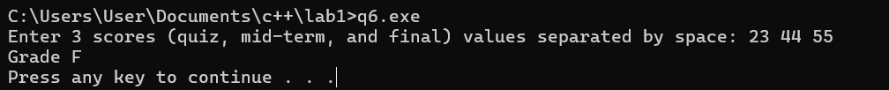

1. The area of a rectangle is the rectangle’s length times its width. Write a program that asks for the length and width of two rectangles. The program should tell the user which rectangle has the greater area, or if the areas are the same.

**Output sample:**

Rectangle A:

Width = 2

Height = 4

Rectangle B:

Width = 3

Height = 10

Area in rectangle B is bigger rectangle A.

*[Estimate Finish Time: 15 minutes]*

*Code:*

Output:

1. Compute the total cost of a meal inclusive of GST (Goods and Service Tax) and tipping. Assume that the GST is fixed at 6% but the amount to tip will depend on the customer. Your program should input the cost of the meal (before GST and tipping) and the tip amount (to be input as a percentage).

Your program should display:

*The total cost of the meal BEFORE GST and tipping*

*The total cost of the meal AFTER GST*

*The total cost of the meal AFTER GST and tipping*

**Code:**

Output:

